SAMFYA SECONDARY SCHOOL
CHEMISTRY LESSON PLAN
GRADE | TOPIC | SUB TOPIC | DURRATION | DATE
10 | Separation technique | Evaporation | ____min | ____/___/__

RATIONALE : Evaporation is a separation technique used to separate a solid from a liquid in which the solid has dissolved. It will help learners to separate mixtures. Group/ pair work and demonstration will be used to execute the second lesson of seven in the series.
SPECIFIC OUTCOMES, LSBAT: - demonstrate how evaporation is done.
- Identify the substances that are separated by evaporation.
- Explain the use of the water in the beaker.
PRE-REQUISITE SKILLS : learners have knowledge on separation.
TEACHING/ LEARNING AIDS : chemistry key point’s pupils book 10.
REFFERENCES : chemistry 10, chemistry made clear. Certificate
Chemistry 4th edition.
LESSON PROGRESSION
STAGE | T/L ACTIVITY | LEARNING POINTS
INTRO-  DUCTION  ____min | Revise on how certain substances are separated.
D  E  V  E  L  O  P  M  E  N  T  ____min | ACTIVITY 1 (discussion )  This is a separation technique used to separate a solid from a liquid in which the solid has dissolved.  Investigation: The separation of a salt solution  Aim: To demonstrate that a homogeneous salt solution can be separated using physical methods. Apparatus: glass beaker, salt, water, retort stand, bunsen burner.  Method:  - Pour a small amount of water (about 20 ml) into a beaker.  2. Measure a teaspoon of salt and pour this into the water.  3. Stir until the salt dissolves completely. This is now called a salt solution. This salt solution is a homogeneous mixture.  4. Place the beaker on a retort stand over a bunsen burner and heat gently. You should increase the heat until the water almost boils.  5. Watch the beaker until all the water has evaporated. What do you see in the beaker? | 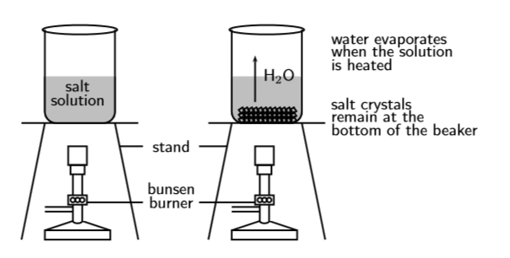  Results: The water evaporates from the beaker and tiny grains of salt remain at the bottom. Conclusion: The sodium chloride solution, which was a homogeneous mixture of salt and water, has been separated using heating and evaporation.
C  O  N  L  U  S  I  O  N  ____min | Go through the important points

EVALUATION: ……………………………………………………………………………………………………………………………………………………………………………………………………………………………………………………………………………………………………….

